**1) Use Watson APIs to create Language Translator Service.**

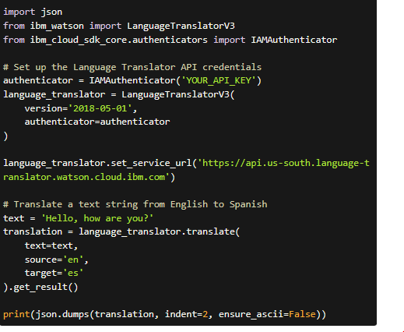

**2. Create an instance of the Language Translator Service in your Python code.**

**3. Create a function that translates English to French.**

You can call this function with any English text to translate it to French. For example:

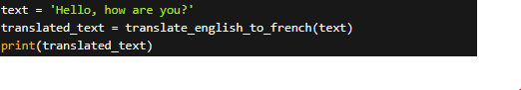

This will output the translated text:

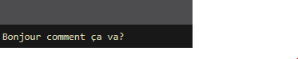

**4. Create a function that translates French to English.**

You can call this function with any French text to translate it to English. For example:

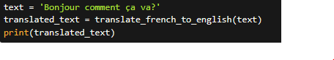

This will output the translated text:



**5. Write unit tests to test the englishToFrench function with assertEqual and assertNotEqual.**

**6. Write unit tests to test the frenchToEnglish function with assertEqual and assertNotEqual**

**7. Run coding standards check against the functions above.**

There are several coding standards checkers available for Python, but one popular tool is flake8, which checks your code for PEP 8 style guide violations as well as other potential issues.

To run flake8 against your code, you can follow these steps:

1. Install flake8 using pip by running pip install flake8 in your terminal or command prompt.
2. Navigate to the directory containing your my_module.py file and run flake8 my_module.py.

flake8 will then output any style guide violations or other issues it finds in your code. You can then fix these issues to ensure your code adheres to best practices.

Note that flake8 is just one tool for checking coding standards, and there are many others available with different features and capabilities. It's always a good idea to run several different tools against your code to ensure you catch as many potential issues as possible.

**8. Run unit tests and interpret the results.**

9. Package the above functions and tests as a standard python package.

1. Create a new directory for your package. You can name it whatever you like (e.g., my_package).
2. Inside the directory, create a file named __init__.py. This file tells Python that the directory should be treated as a Python package. You can leave this file empty.
3. Create a file named translation.py inside the package directory. This file should contain the frenchToEnglish and englishToFrench functions:

1. Create a file named test_translation.py inside the package directory. This file should contain the TestTranslation unit tests:

1. Create a setup.py file inside the package directory. This file tells Python how to install and distribute your package:

To use the frenchToEnglish and englishToFrench functions in another Python script, you can simply import them from your package:

To run the unit tests from your package, you can use the unittest module as usual:

10- Import the package in the server code and provide translation endpoints.

11. Check English to French translation

12. Check French to English translation.

